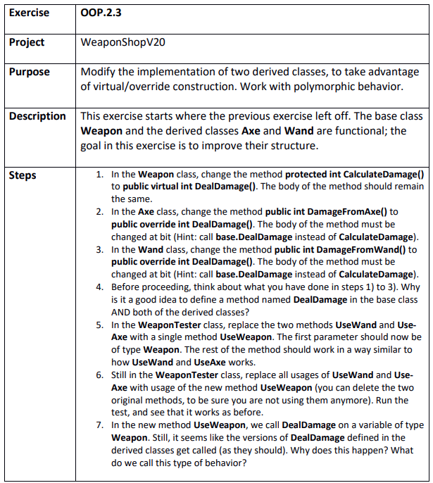

Step 1
WeaponShopV20.sln
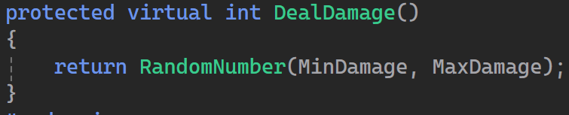

Step 2
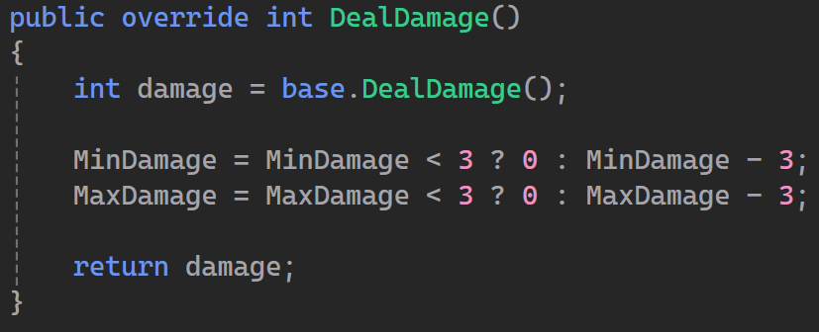

Step 3
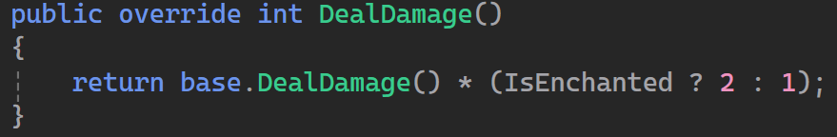

Step 4
It is good to have a basic method implementation that can be used for weapons in general but also can be used within the overridden implementation. It also enables polymorphism so every weapon can use the deal damage though it is different from weapon to weapon

Step 5 & 6
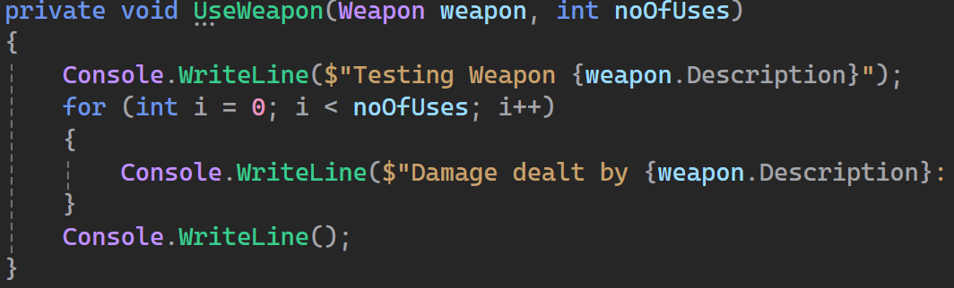

Step 7
Polymorphism. The overridden implementation is always prioritized over the base class implementation of a virtual method.

